  - How to schedule an Appointment with a Counselor
  - Option One: Schedule an appointment through a service
- From your Success Network, scroll down to Your Services, then choose “SCHEDULE” on the service you’d like to meet with.
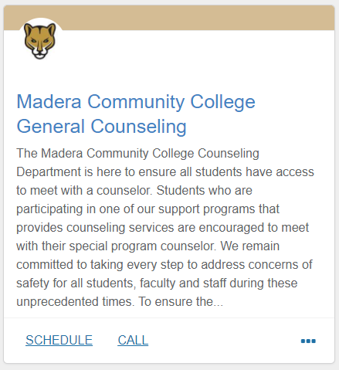
- If you do not see the service for the program that you want to meet with, search in Other Services
- Choose your reason for scheduling the appointment. Each reason is associated with a specific timeframe. For general counseling, you will see the following:
  - General Questions (60 minutes): Get information about a program, adding an additional course, general advising questions.
  - Probation Counseling/Petition Assistance (60 minutes): Discuss probation status, be readmitted to the college after being dismissed, approval of units due to probation status, Course Repeat or other Petitions.
  - Student Education Plan (SEP)/Program Completion Review (60 minutes): Change your major and create a comprehensive semester by semester plan, update your SEP, review external transcripts, etc.
- Find the day/time/counselor you want to see.

Tip: Starfish will only show you two days out. Click on the calendar to look further in the future. Each determines how far out students are able to schedule. If you have questions, contact the program you are interested in scheduling with.
  - *due to COVID – all remote appointments are being scheduled for 60 minutes

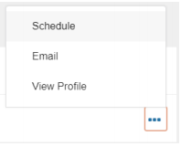
  - Option Two: Schedule an appointment with a specific person
- From your Success Network, under Your Connections, you will see your primary counselors if you have them. You will have primary counselors if you are part of a program that connects you to a specific counselor.
- If you know who you are looking for and do not see them right away, use the search bar on top and search for them by name.
- You can see a list of counselors in each service by clicking the title of the service.
- Click the three dots next to the person you want to schedule with and choose schedule.
- Choose one of the appointment types listed, then choose your reason for seeing that counselor.
- Find the day/time that works for you.

